**October 2019**

MORROW MIDDLE SCHOOL

Morrow Middle School

2019-2020

Communication Checklist

Be sure to register and check out the following methods we use to communicate with us!

I have registered for the Infinite Campus Parent Portal to access my child’s grades

electronically. Visit the front office to register. I check IC with my child weekly.

I follow my student’s accounts via Google Classroom.

I have subscribed to each of my child’s Class DOJO accounts with his/her classroom

teacher.

I visit the school’s website frequently for updates -http://015ccps.ss10.sharpschool.com/

I have the email addresses of my child’s teachers.

My child has to read to a parent or guardian daily for 30 minutes.

My child has to practice iReady reading and math for 30 minutes each day.

I check and initial my child’s class agenda every day.

Let’s Talk Tuesdays- Parents can call the main office to schedule conferences with teachers

24-48 hours in advance. Every Tuesday, 4:00 p.m. – 5:00 p.m.

Please be advised that students will not be allowed to bring cell phones to class. Each

morning students are expected to place cell phones in their lockers. Parents will

contact the main office for emergencies to speak with students. It is imperative that

students concentrate and focus on instruction during class time. As always, thank you

for your support!



**HISPANIC HERITAGE MONTH— (Sept. 15-Oct. 15)**

**OCT 1st-—FOOTBALL GAME @ ADAMSON**

**OCT 2nd—VOLLEYBALL 1ST ROUND QUARTER FINALS-LOCATION TBA**

**OCT 3RD—VOLLEYBALL SEMI-FINALS @ MUNDY’S MILL MIDDLE**

**OCT 9th-LEARNING AT HOME TIPS WORKSHOP 4PM**

**OCT 10TH—VOLLEYBALL ALLSTAR GAME @ MUNDY’S MILL MIDDLE**

**OCT 14TH—NO SCHOOL-TEACHER WORK DAY**

**OCT 14TH-18TH—HOMECOMING WEEK**

**OCT 15TH—HOME FOOTBALL GAME @ RIVERDALE**

**OCT 18TH-PEP RALLY**

**OCT 22ND—FOOTBALL PLAYOFFS 1ST ROUND**

**OCT 23RD—WALK AND RIDE THE BUS TO SCHOOL DAY 7:45AM**

**OCT 29TH—FOOTBALL PLAYOFFS 2ND ROUND**

**OCT 31st-PICTURE DAY**

# C:\Users\ldpowell\Desktop\from the principal.png

Lawvigneaud D. Harrell Ed.S

Our book fair is happening soon! Join us from November 5th-8th for our book fair. Are you looking for a cash-free way to shop the fair? Our fair is accepting eWallet as a payment option! Visit <http://www.scholastic.com/bookfairs/> to sign up for eWallet and to preview our book inventory. Also, online shopping will be available from 10/31-11/13. Books will be shipped to Morrow Middle for free.

LEVEL UP READING CAMPAIGN CLASS DOJO

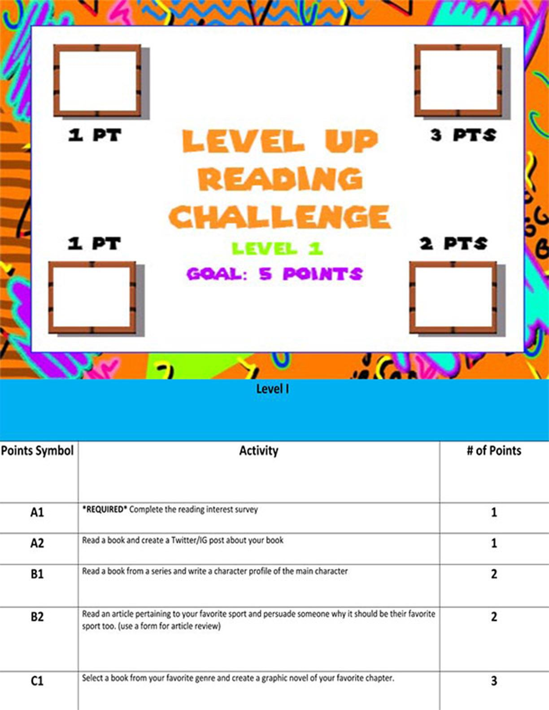



Parents,

Are you signed up for ClassDojo? If you need assistance with signing up, contact your child’s teacher.

STUDENTS,

BE SURE TO COMPLETE THE LEVEL 1 READING CHALLENGE BY NOVEMBER 1st. IF YOU NEED A COPY OF THE LEVEL 1 ACTIVITIES, SEE MRS. CABINESS IN THE MEDIA CENTER.

PTSA MEETING BOOK OF THE MONTH

Seventh-grader Castle “Ghost” Cranshaw joins a track team and struggles to deal with his past and his present. As a child, Ghost had to flee his apartment with his mother when his father, in a drunken rage, tried to kill them.

Wouldn’t you like to read more?

See the media specialist to pick up a copy of the BOTM!

WHEN: OCTOBER 10TH

TIME: 6:00pm

WHERE: MEDIA CENTER





COME AND BE ENLIGHTENED! ENJOY REFRESHMENTS, WIN PRIZES & MUCH MORE!

When: OCTOBER 24TH

Where: MMS

Time: 9:00AM



GIRLS BASKETBALL TRYOUTS

BOYS BASKETBALL TRYOUTS



TRYOUT DATES:

OCTOBER 7TH-11TH

NOTE: ALL FORMS MUST BE RETURNED TO COACH FREEMAN BEFORE YOU ARE ALLOWED TO PARTICIPATE IN TRYOUTS.

JOIN US AS WE ENJOY EMPOWERING SPEAKER, MR. CHAZ COHEN, REFRESHMENTS AND MORE!

When: OCTOBER 17TH

Where: MMS

Time: 9:00AM

TRYOUT DATES:

OCTOBER 12TH

6TH GRADERS 10AM-11:30AM

7TH & 8TH GRADERS 12-2PM

NOTE: ALL FORMS MUST BE RETURNED TO COACH FREEMAN BEFORE YOU ARE ALLOWED TO PARTICIPATE IN TRYOUTS.





## DONUTS FOR DADS MUFFINS WITH MOM